**UNIVERSITY ADMIT ELIGIBILITY PREDICTOR**

**ABSTRACT**

University rankings have grown significantly in prominence in recent years, not just among academics but also among students, parents, the business community, and industry. The students and their parents, who are common stakeholders, may not be familiar with the nuances of ranking methods and aspects / criteria of rankings, but they are undoubtedly interested in learning where the University stands on how much the ranking lists interested them. The most frequent and widely used university ranking systems and evaluations will be reviewed, along with their current trends and approaches, in this study. Various quantitative and qualitative criteria will also be described. The issue of student admission is crucial to university entrance. In this research, machine learning algorithms are used to forecast a student's likelihood of enrolling in a university. This will help the pupils understand the next step if they are accepted. The capability of early university prediction based on student academic performance tendencies. It is very significant for graduate students and beneficial for tutors. The goal of this study is to determine which machine learning method is best effective at forecasting university informatics based on students' graduation marks or grades. This leads to the selection of academic courses, each of which serves as a unique dataset, and the testing of well-known classification methods. The primary research obstacles of the current work are the datasets and the unbalanced distribution of class values. For the first time in a performance prediction application, a number of strategies are used to overcome these problems, including feature selection. In comparison to other prediction methods, Support Vector Machine produced the best results, which are highly satisfying those with comparable philosophies.

1. **INTRODUCTION**
   1. **PROJECT OVERVIEW**

In the current world scenario, it is not enough for a student to just have an Under Graduate degree. A lot of students from anywhere prefer to continue their higher education with foreign universities, especially in the United States. In order to get admitted to these foreign universities, a set of academic requirements are needed. However, because of the sheer number of universities of different levels, students are often stuck in a dilemma till the very last minute as to whether or not their applications will be accepted or not as no concrete documentation is available which lists the requirements. AI based application that asks for the users to input their academic transcripts data and calculates their chances of admission into the University Tier that they selected. It accurately and precisely predicts student data and gives them an estimate of their prospects of being admitted to the universities of their choice. In this research, machine learning algorithms are used to forecast a student's likelihood of enrolling in a university. This will help the pupils understand the next step if they are accepted. The capability of early university prediction based on student academic performance tendencies. It is very significant for graduate students and beneficial for tutors. The goal of this study is to determine which machine learning method is best effective at forecasting university informatics based on students' graduation marks or grades.

* 1. **PURPOSE**

The purpose of this project is a web application that allows users to enter their academic data and get predictions of their chances of admissions in the university tier of their choosing. It also provides an analysis based on the data set used that shows how the different parameters affect chances of admissions. This system which will help the students to predict the chances of their application being selected for a particular university for which they wish to apply based on their profile. Also, the system will provide a recommendation of universities to the student to which the student has a high possibility of getting admission. Multiple machine learning classification algorithms were evaluated to develop the system.

1. **LITERATURE REVIEW**
   1. **EXISTING PROBLEM**

**2.1.1 TITLE:** A Machine Learning Approach for Graduate Admission Prediction

**AUTHOR:** Amal AlGhamdi, Amal Barsheed, Hanadi AlMshjary

It is getting harder for graduates to get into their preferred university as there are more grads who want to continue their studies. Newly graduated students frequently lack awareness of the criteria and processes for postgraduate admission and may spend a significant sum of money on consulting services to help them determine their prospects of admission. This method may be biassed and erroneous, nevertheless, given the small number of colleges that a human consultant can take into account. To help graduates choose and target the universities that are most appropriate for their profile, a machine learning approach is created in this study to automatically forecast the chance of postgraduate admission. In order to estimate the university rate given the student profile, this study compares three regression learning strategies: logistic regression, decision trees, and linear regression. This essay assesses different models in order to determine which one has the best accuracy and error rates. In our studies, the logistic regression model provides the most accurate prediction, thus we advise using it to forecast a prospective applicant's likelihood of being admitted to a certain university. Algorithms for machine learning, such as the Logistic Regression Model, Decision Tree Model, and Linear Regression Model. The experimental setup is covered in Section IV, together with the dataset, features, correlations, and data visualisation. While Section VII shows and discusses the outcomes of the examined models, Section V describes the implementation and assessment methodologies. The paper is concluded in Section VIII, which also offers some suggestions for further research.

**2.1.2 TITLE:** Pediatric Severe Sepsis Prediction Using Machine Learning

**AUTHOR:** Sidney Le, Jana Hoffman1

In order to maximise the effectiveness of treatment, it is essential to identify paediatric severe sepsis early. To do this, new techniques are required. The University of California San Francisco (UCSF) Medical Center provided a retrospective set of de-identified paediatric inpatient and emergency interactions for patients aged 2 to 17 years old. The encounter dates ranged from June 2011 to March 2016. De-identified chart data from paediatric inpatient and emergency contacts (ages 2–17) at the University of California San Francisco (UCSF) Medical Center, from June 2011 to March 2016, inclusive, were used in these trials (35). For more information on data inputs, see Table 1. Infants younger than two years old have immature adaptive and innate immune responses (36), which call for separate examination outside the purview of our work. Since all data were de-identified prior to the start of this study in accordance with the Health Insurance Portability and Accountability Act (HIPAA) Privacy Rule and no individual patient data were linked before being de-identified, the initial UCSF data collection had no negative effects on patient safety.Consequently, this research uses non-human participants and does not require Institutional Review Board approval. This implies that a patient may be found to have met our retrospective definition if, as before they satisfy the surveillance standards for being "septic," or "severe sepsis." For instance, if laboratory results that met the criteria for organ dysfunction were available before fever and tachypnea were noted in vital sign flowsheets, the patient would be diagnosed with severe sepsis. This feature was deemed essential in order to reflect the clinical procedure and avoid issues with noise threshold satisfaction.

**2.1.3 TITLE:** Graduate Admission Prediction

**AUTHOR:** B.MOUNIKA, G.S.K.CHAITANYA

Today's students frequently pursue their education outside of their own nations. These international students mostly aim to study in the United States. that America. India and China account for the majority of foreign students in the United States of America. The number of Indian students enrolling in postgraduate programmes in the USA has sharply increased during the last ten years. Each candidate must compete fiercely to be admitted to their ideal university given the rise in the number of international students studying in the United States. The students typically seek assistance from education consulting firms to help them successfully secure admission in the universities that are best suited for their profile because they have little knowledge of the procedures, requirements, and specifics of the universities in the USA. For this, they must invest a significant sum of money in the form of consultancy fees. There are a few websites and blogs that offer advice to students on the admissions process in addition to these education consultant organisations. The current resources have the disadvantage of being quite scarce and also not being particularly dependable when it comes to correctness and reliability. This project's goal is to create a system employing machine learning methods. We'll call it the Graduate Admission Predictor. The students will benefit from knowing the likelihood that a university will approve their application. With the aid of various machine learning algorithms like Multi Linear Regression, Polynomial Regression, and Random Forest, we will be able to determine which method will produce correct results. For users to access the system, a straightforward user interface will be created.

**2.1.4 TITLE:** College Admission Prediction using Ensemble Machine Learning Models

**AUTHOR:** Vandit Manish Jain1, Rihaan Satia

In order to help students choose the best universities for them based on their profiles, this study tries to develop a model. We are capable of making judgments in a wide range of fields, such as M.S. (international), M.Tech. (India), and MBA (India and worldwide). We intend to build a machine learning model to make correct predictions in order to deliver outcomes. The dataset includes characteristics on the student profile and the university, together with a field that indicates whether or not the admission was successful. Key performance indicators have been used to compare the predictions made using a variety of algorithms, including Ensemble Machine Learning (KPIs). The dependent variable, or the likelihood of admission to a university, is then evaluated using the model that is performing the best. The odds of admit variable, which has a range of 0 to 1, represents the anticipated likelihood of being accepted to a university. Additionally, we want to build a gateway that sorts institutions according to their acceptance range before listing them. One can enter their scores in the corresponding fields of the system that has been proposed. The system then evaluates the data entered and generates a list of universities a person could enrol in based on their test results. This is reasonably swift and saves both time and money. We have suggested an innovative approach using machine learning techniques to do this. We have considered multiple machine learning algorithms in order to increase the accuracy of our model. Neural networks, linear regression, decision trees, and random forests are some of these techniques. The Methods portion of this paper will go into further detail regarding these algorithms.

**2.1.5 TITLE:** Data Analysis of Admission Statistics and Comprehensive Study and

Development of Machine Learning Based Prediction Models

**AUTHOR:** Chirayu Darji

The likelihood of admission is based on a number of factors that affect university admissions. It is hence a very difficult and perplexing process. The process is quite expensive because students often shortlist 7–12 universities and must submit applications to each of them. Additionally, it often takes the admissions committees of institutions 3 to 4 months to review the applications and respond with a decision of acceptance or rejection. Therefore, machine learning-based predictive models are researched, created, and used to forecast the likelihood of admission for the candidate's profile in order to save the applicant's valuable time and money. But after completing tests, it was found that the models for linear regression and ridge regression had the maximum accuracy for the provided dataset. In addition, the project would examine the dataset to discover solutions to frequently requested problems from candidates through data analysis and visualisation. This analysis sheds light on how several parameters affect the admissions process. In addition, the algorithm narrows down the candidate's options for universities based on his profile and other factors. In general, having a solid profile that meets the requirements of the institutes is the most crucial stage in securing admission to graduate programmes. However, the application procedure is extremely difficult, time-consuming, expensive, and perplexing. The typical application fee is $125, and it takes the admissions office about 3–4 months to notify applicants of their acceptance or rejection. Therefore, in order to facilitate the process for the students, this project will aid them in comprehending the significance of numerous admissions criteria, forecast their chances of acceptance, and assist them in narrowing down their top university choices.

* 1. **REFERENCES**

1. Amal AlGhamdi, Amal Barsheed, Hanadi AlMshjary, A Machine Learning Approach for Graduate Admission Prediction, 2020.
2. Sidney Le, Jana Hoffman1, Pediatric Severe Sepsis Prediction Using Machine Learning, 2019.
3. B.MOUNIKA, G.S.K.CHAITANYA, Graduate Admission Prediction, 2021.
4. Vandit Manish Jain1, Rihaan Satia,College Admission Prediction using Ensemble Machine Learning Models, 2021.
5. Chirayu Darji, Data Analysis of Admission Statistics and Comprehensive Study and Development of Machine Learning Based Prediction Models, 2022.
   1. **PROBLEM STATEMENT DEFINITION**

In existing system, there are various websites and web apps over the internet which helps students to know their suitable universities. But most of those systems only used personality traits as the only factor to predict the university, which might result in an inconsistent answer. There are several portals and websites which provide information and help to students in short listing the universities, but they are not reliable. Most students hire education consulting companies to evaluate the universities for them rather than taking the chance of doing it themselves. Again, pupils must pay the education consultant a sizable charge for this.

1. **IDEATION & PROPOSED SOLUTION**
   1. **EMPATHY MAP CANVAS**

* 1. **IDEATION & BRAINSTORMING**
  2. **PROPOSED SOLUTION**

Using this project, a user can analyse the likelihood of getting admitted or not by entering directly their educational background and chosen university of choice. They can also make their own predictions about which university among the many listed will suit them the best. Options based on his academic performance, area of interest, and educational background. This is one of the driving forces behind extensive study on university classification using data mining, which has its own advantages when applied in various fields. To address these issues, the proposed system  is to make a use of the machine learning models. That is, students do not need to visit numerous university websites to learn about the admission requirements of the targeted university. The student only needs to enter their information into the application, and it will automatically determine the likelihood that they will be admitted to one of the several colleges in our database. By comparing the student sample data to the trained model, which will be categorising and forecasting based on a support vector machine algorithm, the programme will also help the student by predicting the most appropriate university the student would be able to receive admission to Model.

* 1. **PROBLEM SOLUTION FIT**

Information are very limited and also they are not truly dependable taking into consideration of their accuracy and reliability. This application will help the student by predicting the most appropriate university that the student would be able to receive admission to Model. The suggested system will allow the user to interact and getting admission chance in a University. Without wasting time on multi website, students can get the admission through trained data, predict the admission quickly

1. **REQUIREMENT ANALYSIS**
   1. **FUNCTIONAL REQUIREMENT**

**Dataset Upload**

In this module, the university datasets should be uploaded as CSV files. Additionally, the information is kept in a database for later use. The dataset includes information on the course details, university rating, chance of admit and other aspects of university. These details are preserved as integer values and acquired from the Kaggle website.

**User Enrolment**

After registration, the user can login in this application using registered username and password. Then the user has to give input by upload their qualification details to get the university admission.

**Classification**

Classification is the process of dividing data into various categories. The method starts by determining the class of the given data points. Classification is achievable for both structured and unstructured data. The terms target, label, and classes are occasionally used to describe the classes. After upload the qualification details, it will be compared with the dataset in the system for the features obtained in the feature extraction stage in classification process. The specific qualifications will be recognized once the ideal match is discovered based on the qualities matched. The detected university name with its details of rating, course details, university facilities and other aspects will be appeared to the user.

**Predict University**

In this module, the user can view the predicted university with its details includes chance of admission, course details, rating of university, university facilities and other aspects of predicted university. Use Machine learning model with SVM algorithm and pre-trained data, the system will predict the admission of university.

* 1. **NON FUNCTIONAL REQUIREMENTS**

**Usability**

The system shall allow the users to access the system with pc using web application. The system uses a web application as an interface. The system is user friendly which makes the system easy

# Availability

The system is available 100% for the user and is used 24 hrs a day and 365 days a year. The system shall be operational 24 hours a day and 7 days a week.

# Scalability

Scalability is the measure of a system's ability to increase or decrease in performance and cost in response to changes in application and system processing demands.

# Security

A security requirement is a statement of needed security functionality that ensures one of many different security properties of software is being satisfied.

# Performance

The information is refreshed depending upon whether some updates have occurred or not in the application. The system shall respond to the member in not less than two seconds from the time of the request submittal. The system shall be allowed to take more time when doing large processing jobs. Responses to view information shall take no longer than 5 seconds to appear on the screen.

# Reliability

The system has to be 100% reliable due to the importance of data and the damages that can be caused by incorrect or incomplete data. The system will run 7 days a week. 24 hours a day.

1. **PROJECT DESIGN**
   1. **DATA FLOW DIAGRAMS**

A two-dimensional diagram explains how data is processed and transferred in a system. The graphical depiction identifies each source of data and how it interacts with other data sources to reach a common output. Individuals seeking to draft a data flow diagram must identify external inputs and outputs, determine how the inputs and outputs relate to each other, and explain with graphics how these connections relate and what they result in. This type of diagram helps business development and design teams visualize how data is processed and identify or improve certain aspects.

**LEVEL 0**

The Level 0 DFD shows how the system is divided into 'sub-systems' (processes), each of which deals with one or more of the data flows to or from an external agent, and which together provide all of the functionality of the system as a whole. It also identifies internal data stores that must be present in order for the system to do its job, and shows the flow of data between the various parts of the system.

Admin

User

University Admit Eligibility Predictor

Dataset

**LEVEL 1**

The next stage is to create the Level 1 Data Flow Diagram. This highlights the main functions carried out by the system. As a rule, to describe the system was using between two and seven functions - two being a simple system and seven being a complicated system. This enables us to keep the model manageable on screen or paper.

Input Data

Pre-processing

Noise Filtering

User

Extracted data matched with trained data

Performance Evaluation

* 1. **SOLUTION & TECHNICAL ARCHITECTURE**

A system architecture or systems architecture is the conceptual model that defines the structure, behavior, and more views of a system. An architecture description is a formal description and representation of a system, organized in a way that supports reasoning about the structures and behaviors of the system. System architecture can comprise system components, the externally visible properties of those components, the relationships (e.g. the behavior) between them. It can provide a plan from which products can be procured, and systems developed, that will work together to implement the overall system. There have been efforts to formalize languages to describe system architecture, collectively these are called architecture description languages (ADLs).

**Students**

Register

Login

Upload Qualification details

**Admin**

Upload Dataset

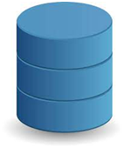

**Database**

Pre-processing

Matched with pre-trained data using SVM algorithm



Give Result



* 1. **USER STORIES**

1. **PROJECT PLANNING & SCHEDULING**
   1. **SPRINT PLANNING & ESTIMATION**
   2. **SPRINT DELIVERY SCHEDULE**
   3. **REPORTS FROM JIRA**
2. **CODING & SOLUTIONING**
   1. **FEATURE 1**
   2. **FEATURE 2**
   3. **DATABASE SCHEMA**
3. **TESTING**
   1. **TEST CASES**

A test case has components that describe input, action and an expected response, in order to determine if a feature of an application is working correctly.A test case is a set of instructions on “HOW” to validate a particular test objective/target, which when followed will tell us if the expected behavior of the system is satisfied or not.

Characteristics of a good test case:

* Accurate: Exacts the purpose.
* Economical: No unnecessary steps or words.
* Traceable: Capable of being traced to requirements.
* Repeatable: Can be used to perform the test over and over.
* Reusable: Can be reused if necessary.

|  |  |  |  |  |
| --- | --- | --- | --- | --- |
| **S.NO** | **Scenario** | **Input** | **Excepted output** | **Actual output** |
| 1 | User login | User name and password | Login | Login success. |
| 2 | Upload Academic Details | Give input in the user defined parameter | Predict the most appropriate university chance of admission. | Predict the most appropriate university chance of admission and stored in a database |

* 1. **USER ACCEPTANCE TESTING**

This sort of testing is carried out by users, clients, or other authorised bodies to identify the requirements and operational procedures of an application or piece of software. The most crucial stage of testing is acceptance testing since it determines whether or not the customer will accept the application or programme. It could entail the application's U.I., performance, usability, and usefulness. It is also referred to as end-user testing, operational acceptance testing, and user acceptance testing (UAT).

1. **RESULTS**
   1. **PERFORMANCE METRICS**

1. **ADVANTAGES & DISADVANTAGES**

**DISADVANTAGES**

* The Existing information are very limited and also they are not truly dependable taking into consideration of their accuracy and reliability.
* The education consultancy firms there are few websites and blogs that guide the students on the admission procedures.
* The students are required to pay the many university for apply courses.

**ADVANTAGES**

* To improve the system's usability and compatibility with users
* Every user will be able to use the application easily because to the user-friendly interface and tips.
* Without wasting time on a visiting many websites.
* Support for Improving Higher Education Quality.

1. **CONCLUSION**

The Primary objective of this work is to make a Machine Learning model which could be utilized by understudies who need to seek after their Education. Many AI algorithms were used for this examination. Support Vector Machine model contrasted with different models gives the best outcome. Understudies can utilize the model to survey their shots at getting induction into a specific University with normal exactness.

1. **FUTURE SCOPE**

In future this module of expectation can be incorporated with module of robotized handling framework and different models like neural organization. Likewise, segregate investigation can be utilized independently or joined for upgrading dependability and precision forecast. At long last, understudies can have an open-source AI model which will assist the understudies with knowing their opportunity of entrance into a specific college with high exactness.

1. **APPENDIX**

**SOURCE CODE**

import numpy as np

import pandas as pd

import pickle

import warnings

# Loading the dataset

df = pd.read_csv('./Data/Admission_Predict.csv')

def clean_dataset(df):

assert isinstance(df, pd.DataFrame), "df needs to be a pd.DataFrame"

df.dropna(inplace=True)

indices_to_keep = ~df.isin([np.nan, np.inf, -np.inf]).any(1)

return df[indices_to_keep].astype(np.float64)

df = clean_dataset(df)

# Replacing the 0 values from ['Glucose','BloodPressure','SkinThickness','Insulin','BMI'] by NaN

df_copy = df.copy(deep=True)

df_copy[['GREScore','TOEFLScore','UniversityRating','SOP','LOR ','CGPA','Research','ChanceofAdmit ']] = df_copy[['GREScore','TOEFLScore','UniversityRating','SOP','LOR ','CGPA','Research','ChanceofAdmit ']].replace(0,np.NaN)

df_copy['GREScore'].fillna(df_copy['GREScore'].median(),inplace=True)

df_copy['TOEFLScore'].fillna(df_copy['TOEFLScore'].median(),inplace=True)

df_copy['UniversityRating'].fillna(df_copy['UniversityRating'].median(),inplace=True)

df_copy['SOP'].fillna(df_copy['SOP'].median(),inplace=True)

df_copy['LOR '].fillna(df_copy['LOR '].median(),inplace=True)

df_copy['CGPA'].fillna(df_copy['CGPA'].median(),inplace=True)

df_copy['Research'].fillna(df_copy['Research'].median(),inplace=True)

df_copy['ChanceofAdmit '].fillna(df_copy['ChanceofAdmit '].median(),inplace=True)

# Replacing NaN value by mean, median depending upon distribution

X=df_copy.drop('ChanceofAdmit ',axis=1)

Y=df_copy['ChanceofAdmit ']

from sklearn.model_selection import train_test_split

X_train,X_test,y_train,y_test=train_test_split(X,Y,test_size=0.2,random_state=42)

X_train.shape,X_test.shape,y_train.shape,y_test.shape

from sklearn.ensemble import RandomForestRegressor

regressor = RandomForestRegressor (n_estimators =1000, max_depth = 10, random_state = 34)

regressor.fit (X_train, np.ravel(y_train, order = 'C'))

# Creating a pickle file for the classifier

filename = 'Model/prediction-rfc-model.pkl'

pickle.dump(regressor, open(filename, 'wb'))

filename = 'Model/prediction-rfc-model.pkl'

pickle.dump(regressor, open(filename, 'wb'))

filename = 'Model/prediction-rfc-model.pkl'

classifier = pickle.load(open(filename, 'rb'))

data = np.array([[337,118,4,4.5,4.5,9.65,1]])

my_prediction = classifier.predict(data)

warnings.filterwarnings("ignore", category=DeprecationWarning)

print(my_prediction[0])

from flask import Flask, render_template, flash, request, session,send_file

from flask import render_template, redirect, url_for, request

import sys

import pickle

import numpy as np

app = Flask(__name__)

app.config['DEBUG']

app.config['SECRET_KEY'] = '7d441f27d441f27567d441f2b6176a'

@app.route("/")

def homepage():

return render_template('home.html')

@app.route("/result", methods=['GET', 'POST'])

def result():

if request.method == 'POST':

t1= request.form['t1']

t2 = request.form['t2']

t3 = request.form['t3']

t4 = request.form['t4']

t5 = request.form['t5']

t6 = request.form['t6']

t7 = request.form['t7']

t1 = float(t1)

t2 = float(t2)

t3 = float(t3)

t4 = float(t4)

t5 = float(t5)

t6 = float(t6)

t7 = float(t7)

filename = 'Model/prediction-rfc-model.pkl'

classifier = pickle.load(open(filename, 'rb'))

data = np.array([[t1,t2,t3,t4,t5,t6,t7]])

my_prediction = classifier.predict(data)

print(my_prediction)

print(my_prediction[0]

out = float(my_prediction[0])

if( out > 0.50):

res = "you are eligible "

else:

res = "you are Not eligible "

return render_template('home.html',res=res)

if __name__ == '__main__':

app.run(debug=True, use_reloader=True)

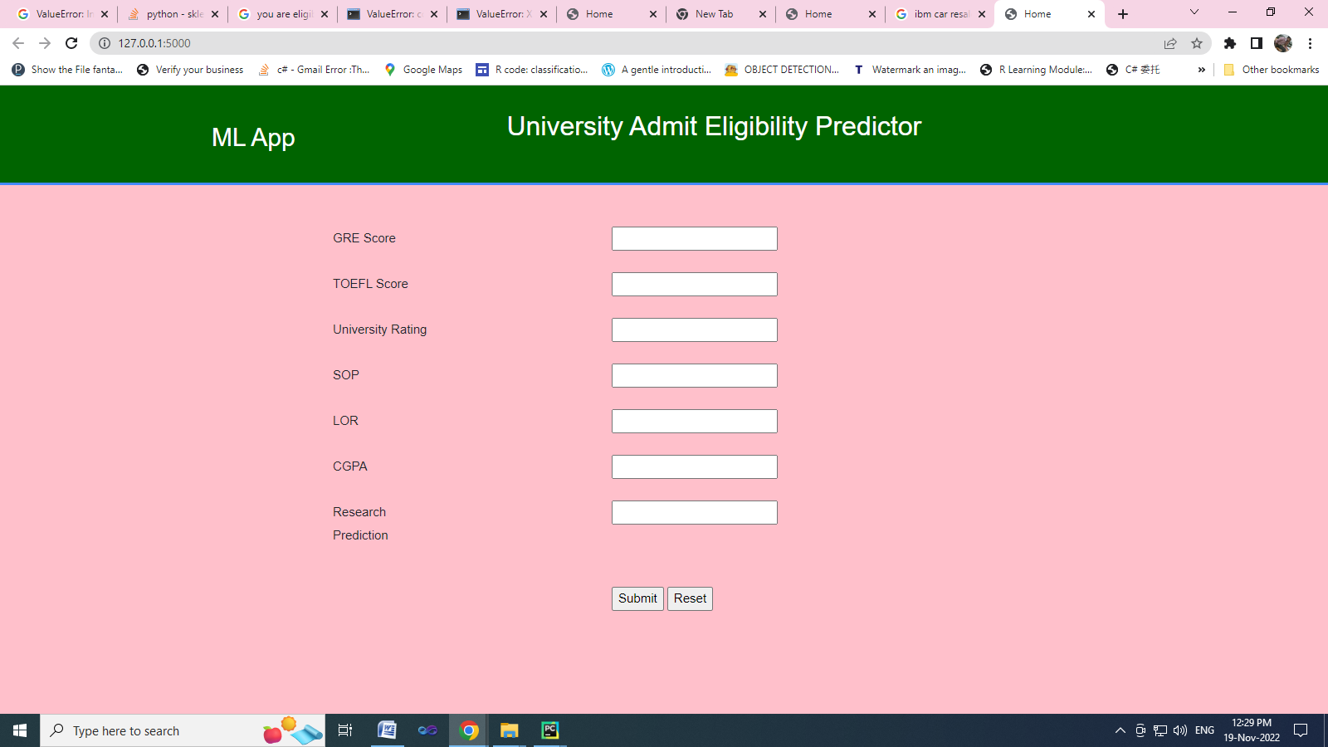

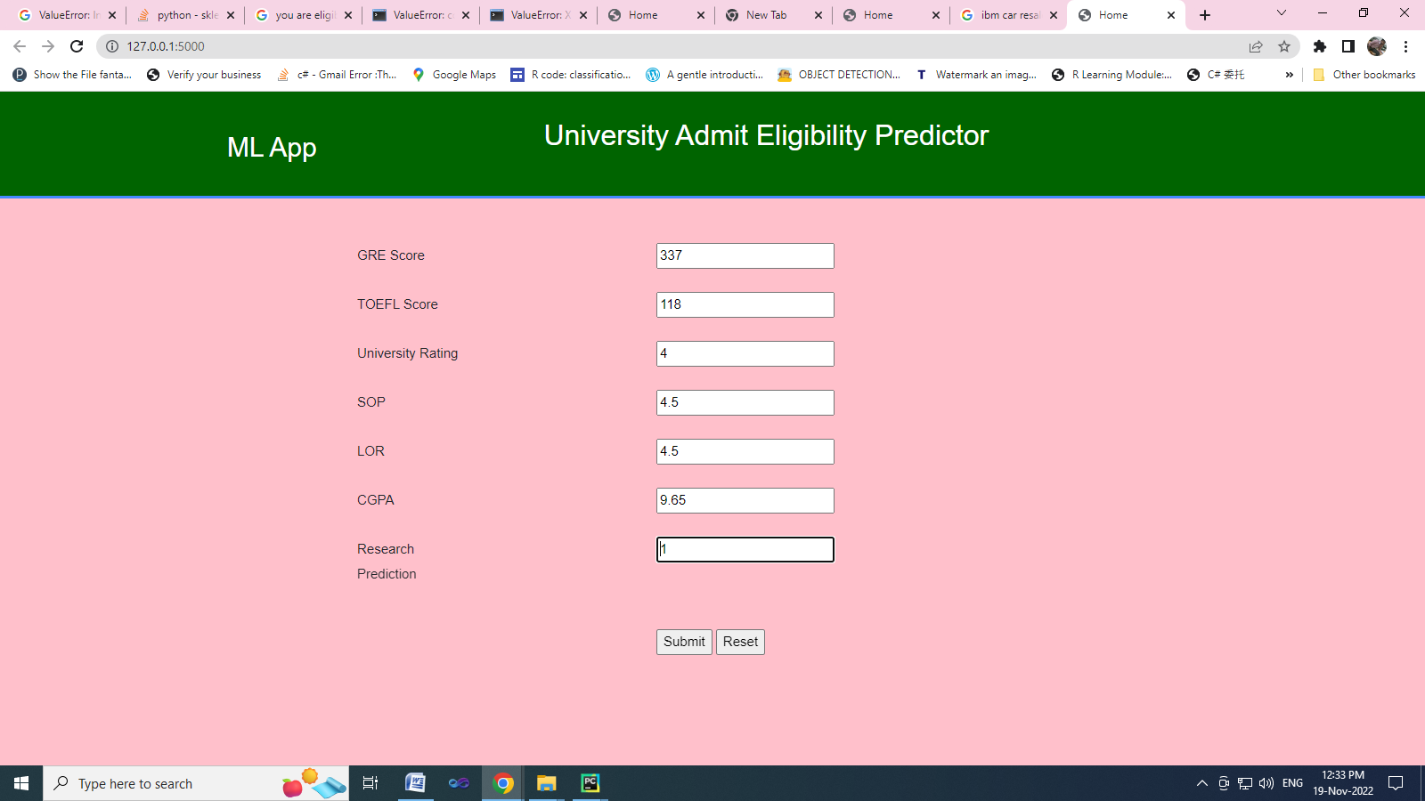

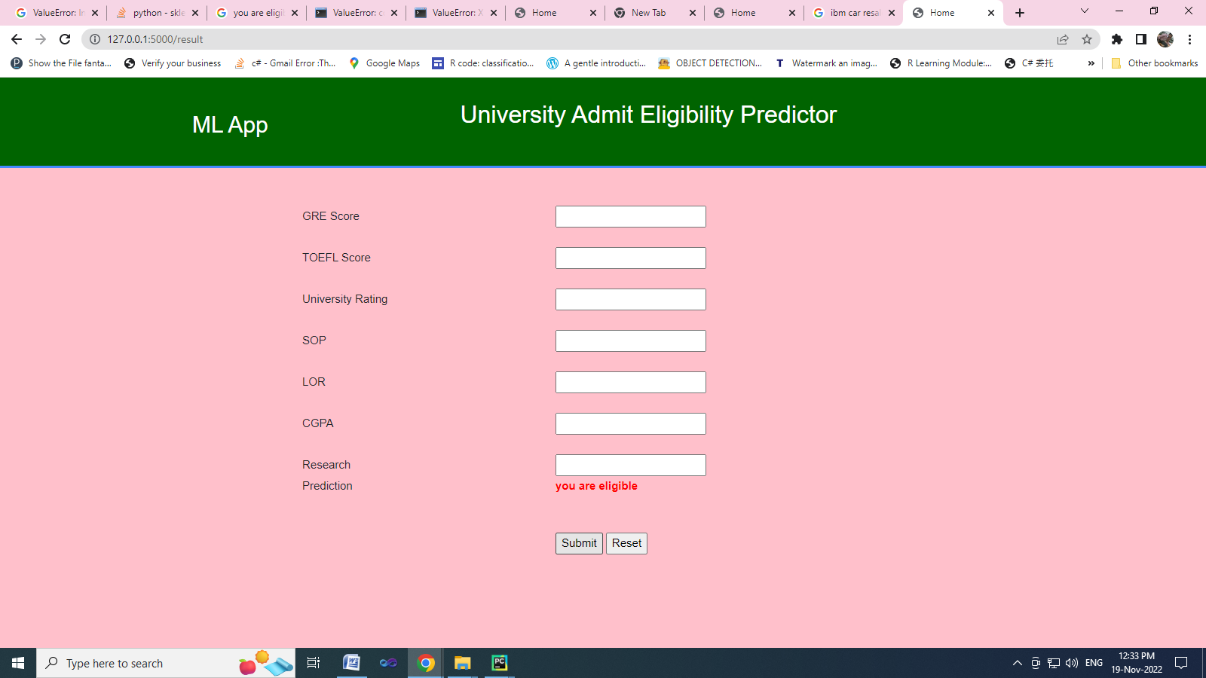

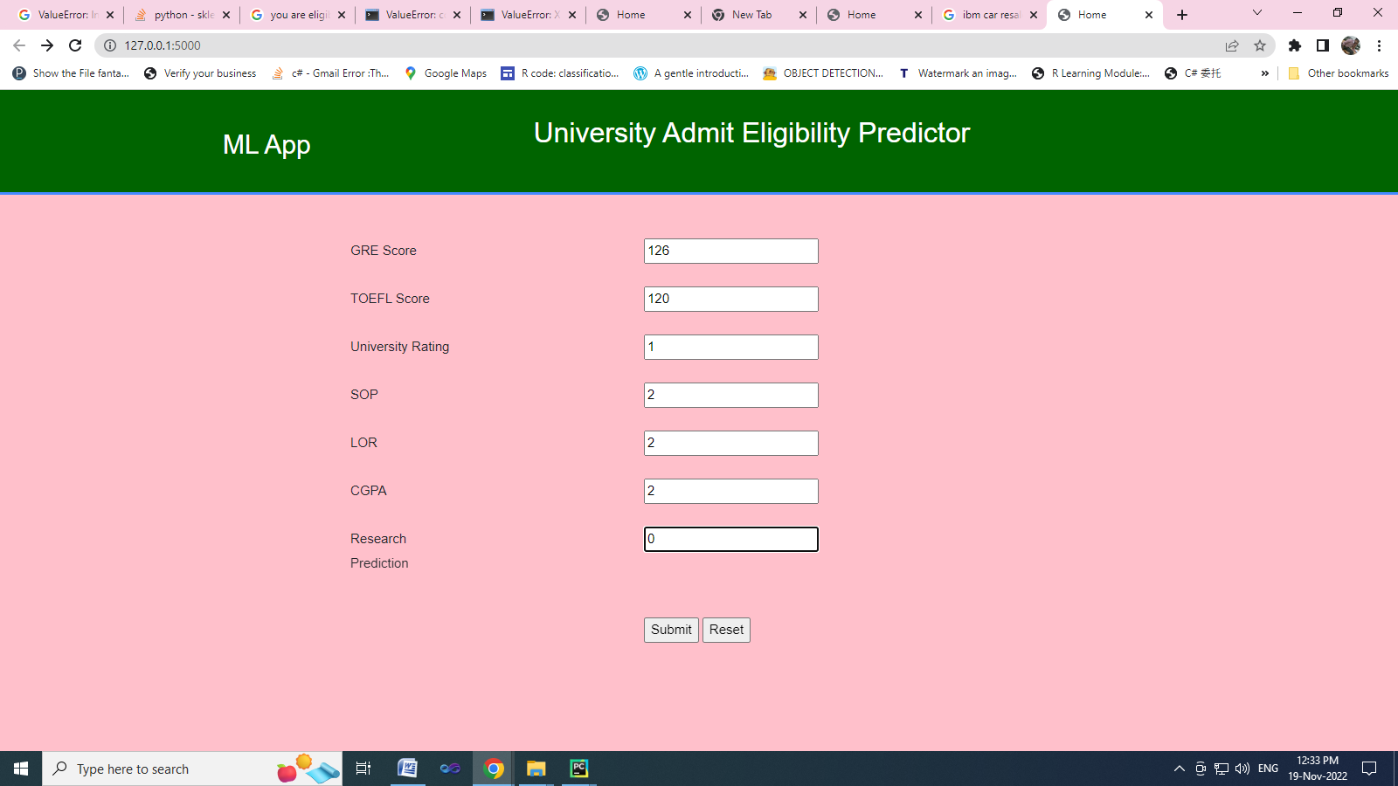

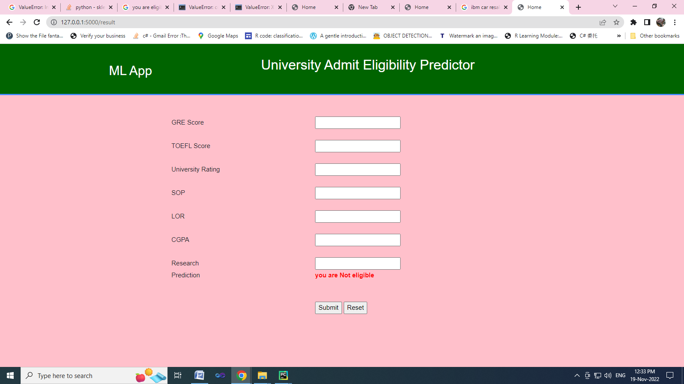

**GITHUB & PROJECT DEMO LINK**